**ATM SYSTEM  
QUESTION:**

Draw a UML diagram for ATM System using CASE tool. The banking system allows a customer to access the financial transactions by ATM System, it has a step-by-step process describe the work of this process and elaborate the what are the work can do by customer, banking system, administrator and technicians with the ATM system.   
**AIM:**

To design a UML Use Case Diagram for an ATM System that illustrates the interactions between actors (Customer, Banking System, Administrator, Technician) and their respective functionalities.  
**PROCEDURE:**

1. Identify Actors:

* Customer: Uses the ATM for transactions like checking balance, withdrawing, depositing, and transferring funds.
* Technician: Handles maintenance and repairs of the ATM.
* Bank: Backend system for transaction processing.

2. Identify Use Cases:

* Check Balance
* Withdraw Cash
* Deposit Funds
* Transfer Funds
* Maintenance (Technician)
* Repair (Technician)

3. Draw Use Case Diagram:

* Use stick figures for actors (Customer, Technician, Bank).
* Use ovals for use cases (e.g., Check Balance, Withdraw Cash).
* Draw dashed arrows between actors and relevant use cases.
* Represent the system boundary (ATM system) enclosing the use cases.

4. Verification: Ensure all actors and use cases are properly linked.

**DIAGRAM:**

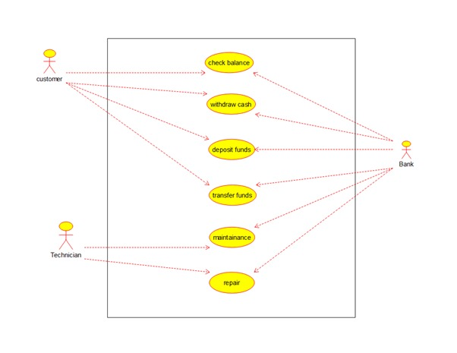

**RESULT:**

The UML Use Case Diagram for the ATM System successfully created.